**A Mini Project Report**

**on**

**“Musifyy : A Music Streaming website”**

Submitted by

**33115 Omkar Dabir**



Department Of Information Technology

Pune Institute of Computer Technology College of Engineering

Sr. No 27, Pune-Satara Road, Dhankawadi, Pune - 411 043.

**A.Y. 2020-2021**

**CONTENT**

|  |  |  |  |
| --- | --- | --- | --- |
| **Sr.** | | **Chapter** | **Page No** |
| **1.** | **Introduction to Text Based Input** | |  |
|  | 1.1 | Introduction to Project | 2 |
|  | 1.2 | Motivation behind project topic | 2 |
|  | 1.3 | Objective(s) of the work | 2 |
| **2.** | **System functionality** | |  |
|  | 2.1 | Function Description | 3 |
|  | 2.2 | Use Case Representation | 4 |
| **3.** | **User Interface Prototype** | | 5 |
| **4.** | **Implementation** | | 8 |
| **5.** | **Conclusion** | | 18 |
| **6.** | **References** | | 19 |

**CHAPTER 1**

**INTRODUCTION**

* 1. **Introduction to Project**

This web project is basically a website for listening to music. Everyone likes to listen to their favourite music. The different songs will be categorized based on genres, artists, etc. which will help users to find exactly what they are looking for. This website will be very useful for searching different songs, organizing them in playlists, i.e. basically personalising the overall music experience.

* 1. **Motivation behind project topic**

Everyone has their own taste of music and hence everyone deserves to have a personalised music experience based on their likings. There are many music streaming websites available like Spotify, Gaana, Saavn, etc. but they contain advertisements and users need to buy premium versions for listening to uninterrupted music. Thus, a free music streaming platform is necessary for those who are not able to buy premium subscriptions for the popular music streaming apps. Additionally, I have a hobby of playing piano(digital keyboard). So I take this opportunity of creating a web project to make the desired music platform to showcase my collection of recordings to others.

* 1. **Aim and Objective(s) of the work**

**Project aims :**  This project aims to build a website which would allow users to choose from a bunch of songs organized into different categories and listen to it easily. The goal is to provide a free, uninterrupted and personalised music experience to the user.

**Project objectives :**

1. To organize different songs based on categories such as genres, artists, languages, etc.
2. To provide a search option for the user to browse any song.
3. To display necessary information related to all the songs.
4. To provide options such as suggestions, playlists and recently played songs to make the experience more personalised.

**CHAPTER 2**

**SYSTEM FUNCTIONALITY**

**2.1 Function Description**

1. User Sign Up / Registration Form with validations for username, password, email.
2. User Authentication and Login functionality.
3. Categorization of different songs based on artists, languages, genres, etc.
4. Display of all the required information about a particular song.
5. Music Player along with Lyrics of the song on the same screen.
6. Functionality to search a song by typing name in the search bar.
7. Ability to like a song, and addition of that song in ‘liked songs’ playlist.
8. Ability to add a song to a particular playlist.
9. Ability to view recently played songs.
10. Suggesting songs based on the user’s interests.

**2.2 Use Case Representation**

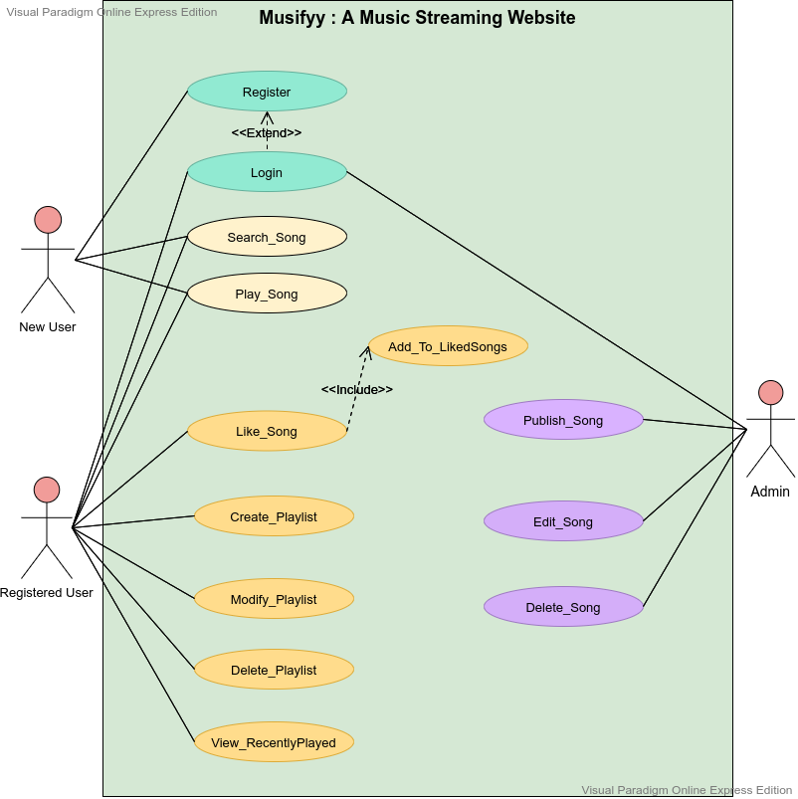

**CHAPTER 3**

**USER INTERFACE PROTOTYPE**

1] Screen1 : Home Page

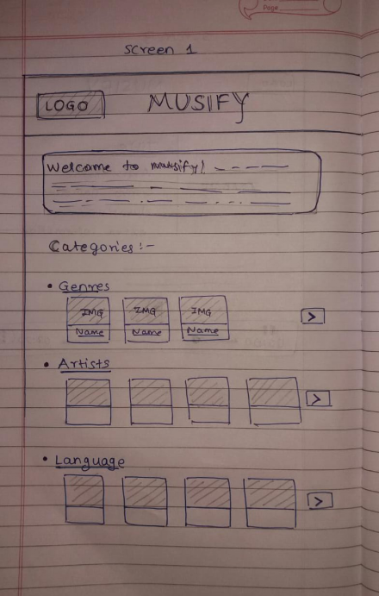

2] Screen2 : Categories Page

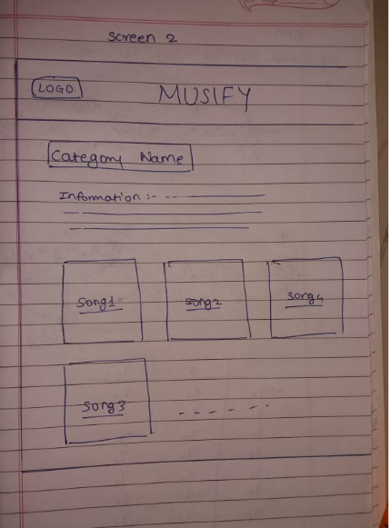

3] Screen3 : songs Page

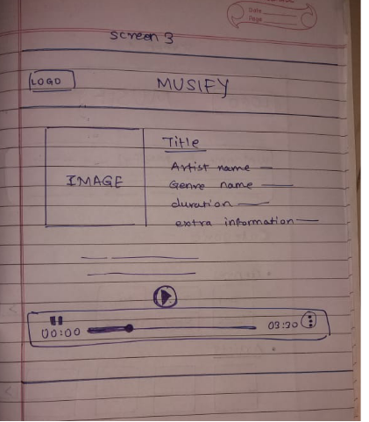

**CHAPTER 4**

**IMPLEMENTATION**

**welcome.html**

This is the welcome page of the website. It contains Login as well as Sign up forms. Both the forms are overlapping each other so that only one form is visible at a time. Users can switch between login / signup form by clicking the link at the bottom of each form. Both the forms have username , password, email validations in javascript which would throw an appropriate error message and display red borders around the particular field as the user types information. If the entered information is valid, the input box turns green. There is also an option to skip login at the top. The user will be automatically redirected to the Homepage once they submit the form successfully.

Basic tags such as <form>, <input>, <label>, <span>, <button>, <a> were used to implement different functionalities. @keyframes were also used to transition between multiple background images. Properties like z-index, perspective, transform : rotate were used for flipping animation of forms. Javascript and regex was used for form validations.

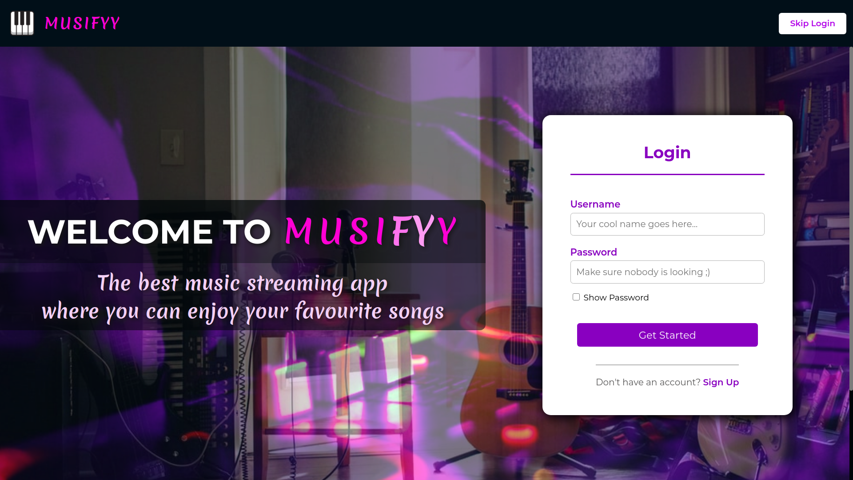

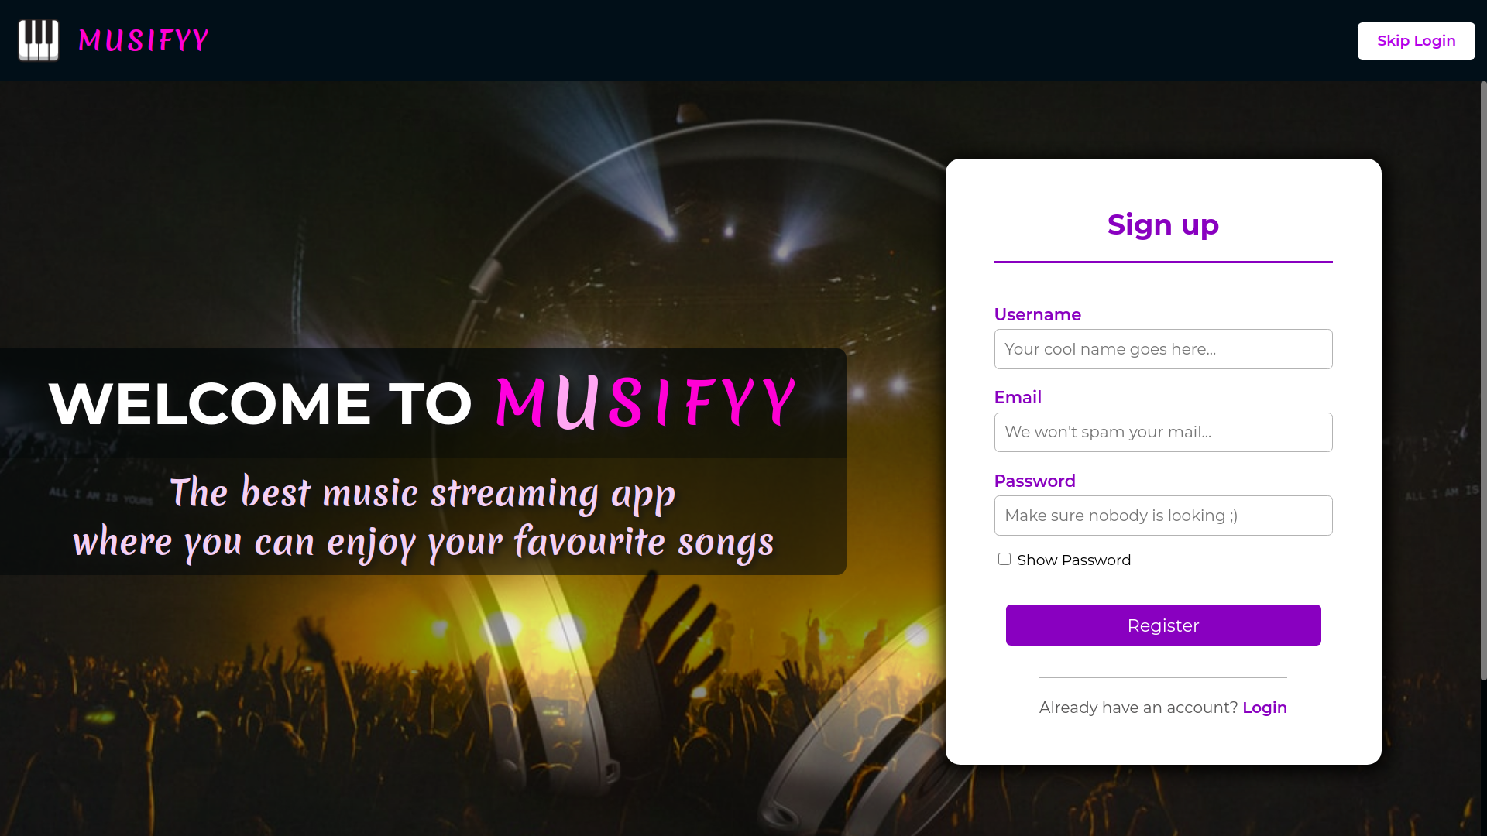

**homepage.html**

This is the main homepage of the website. It consists of a navbar with brand name and logo on the left corner and login/logout options on the right corner along with a footer which has the social media links. The page also has a sidebar to navigate between different tabs such as Home, Recently Played, Playlists, Search. On the central portion of the page, there are various thumbnails of songs/albums categorized based on genre, artists, suggestions, etc. Users can navigate through the thumbnails by clicking ‘previous’ and ‘next’ buttons near each list. Clicking on a thumbnail will redirect users to appropriate pages.

Basic tags such as <header>, <main>, <footer>, <ul>, <li>, <img>, <button>, <a>, <h1>, <h2>, <h3> were used to implement the functionalities. Javascript was used to scroll the thumbnail list.

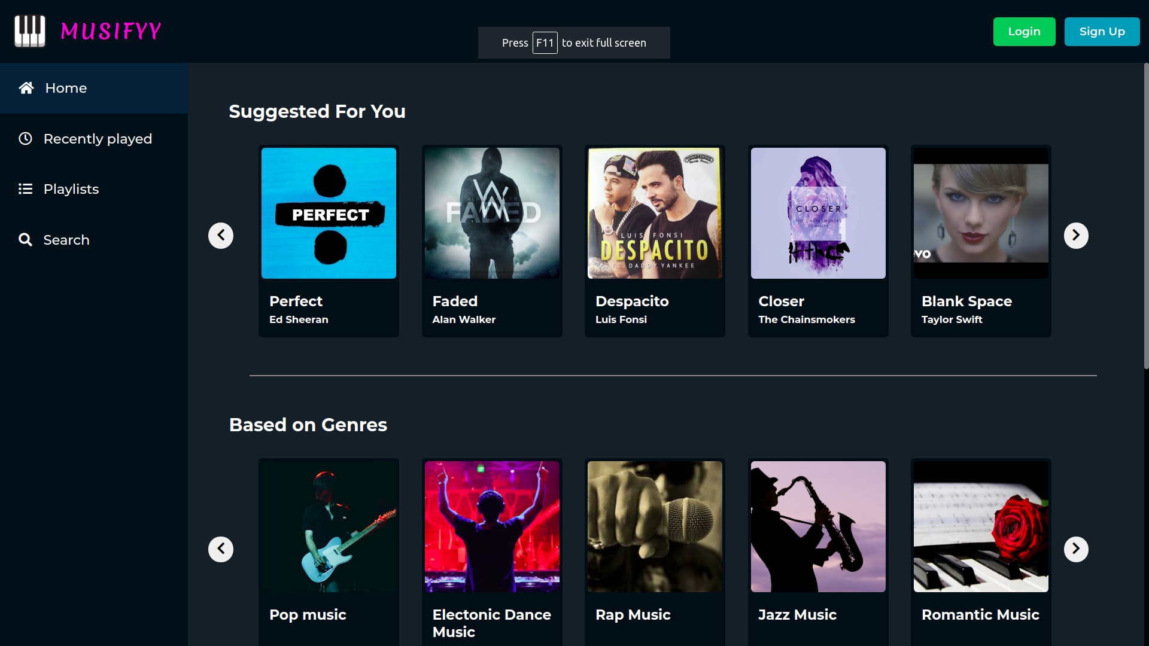

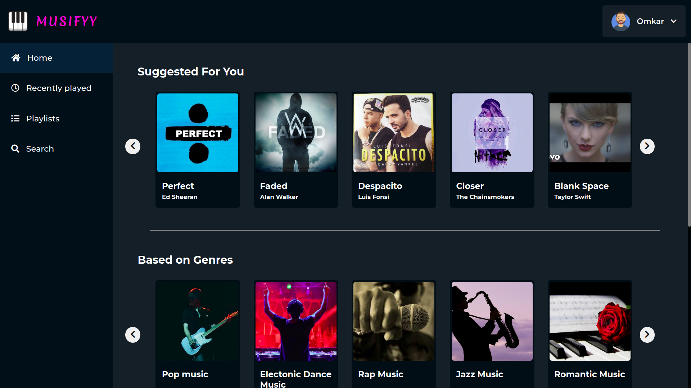

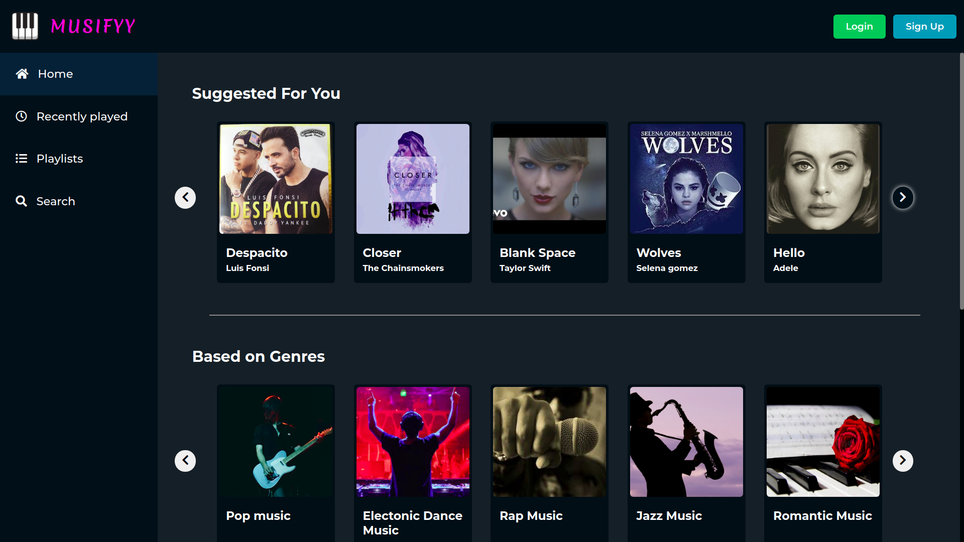

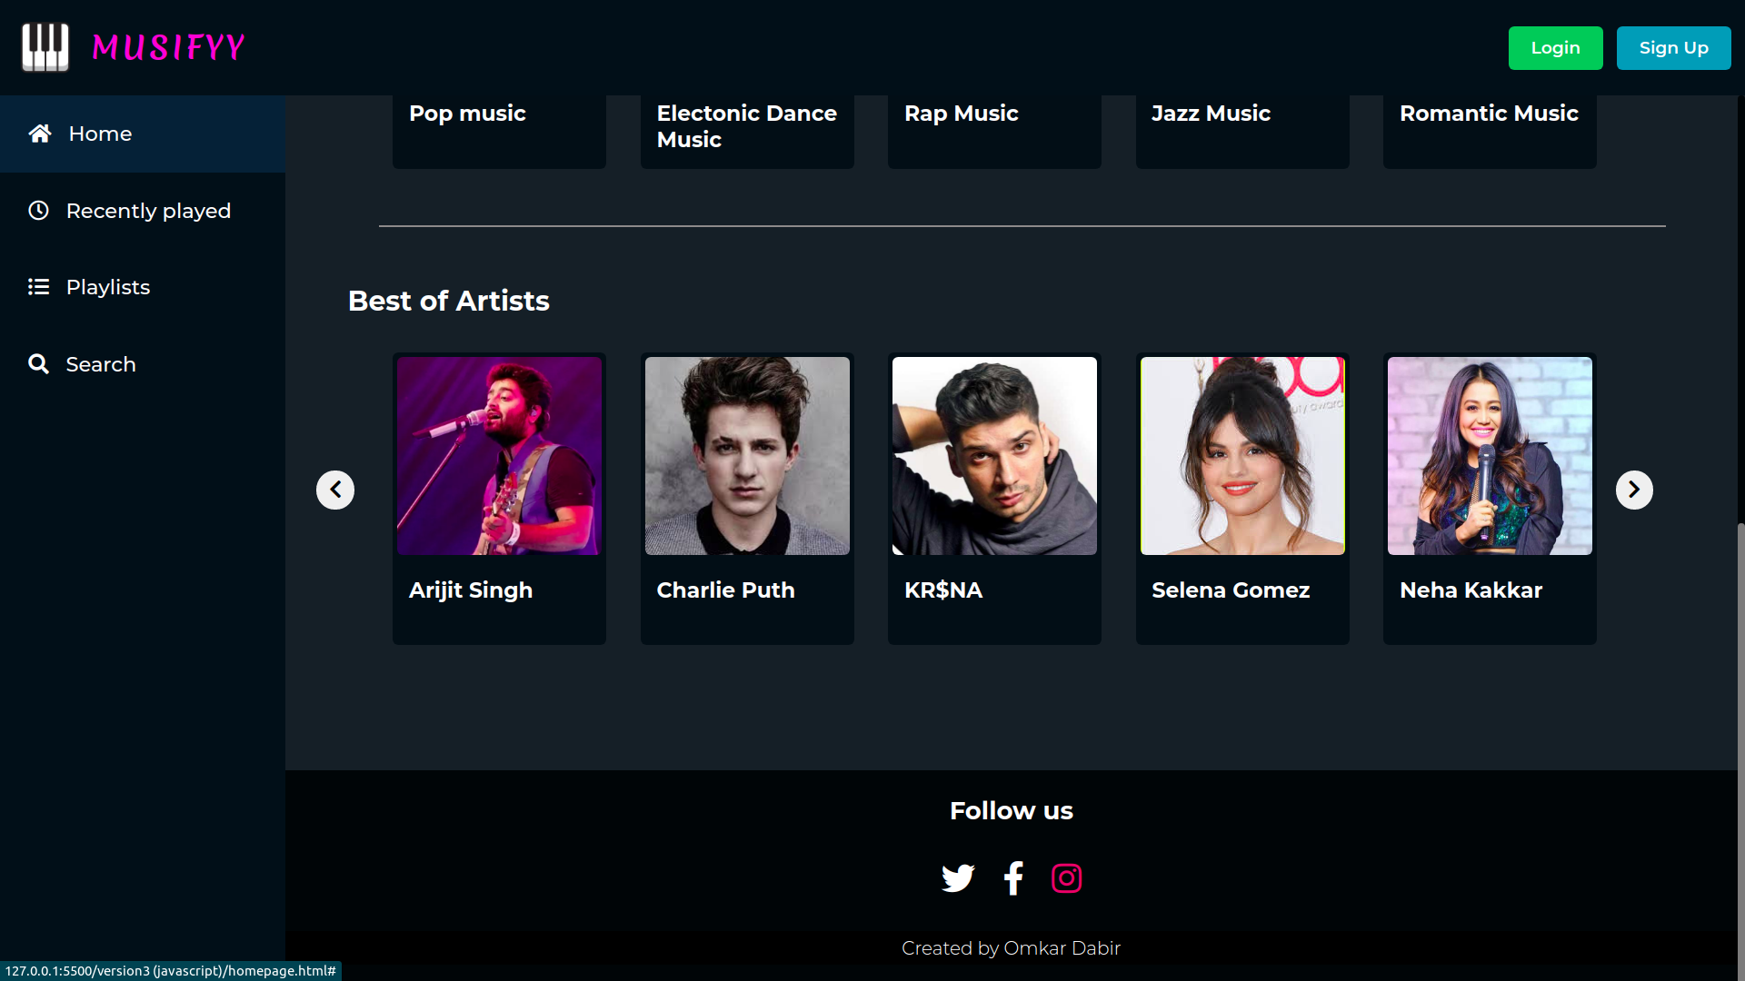

**categories.html**

When a user clicks on a thumbnail of a particular category or an album, they are redirected to this page. This page displays some information related to that category and a list of songs coming under that category in the form of table. The details of the song such as title, release date. duration, artist, etc. is also displayed in the table.

Basic tags such as <ul>, <li>, <img>, <a> were used to implement the functionalities. nth-child selector in css was used to give different background colour to alternate rows of the table.

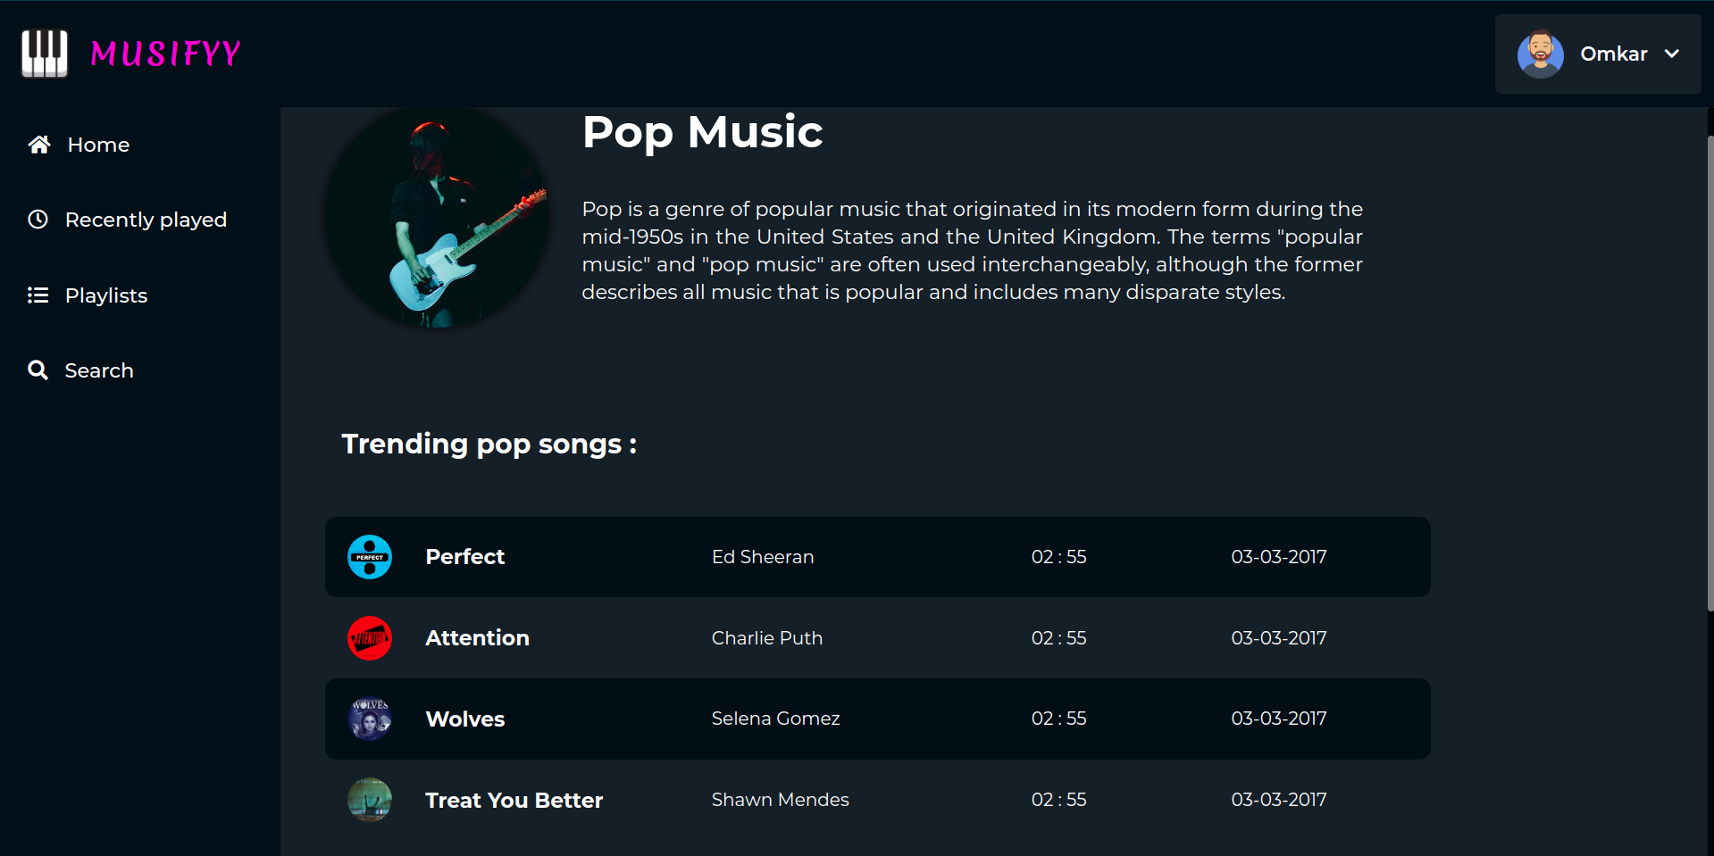

**songs.html**

When a user clicks on a thumbnail of a song on the homepage or the rows in categories table, they are redirected to this page. This page has all the basic information regarding a particular song along with the actual media player which plays the song. Also the lyrics of the song are displayed on the same page.

Basic tags such as <ul>, <li>, <img>, <a> were used to implement the functionalities. nth-child selector in css was used to give different background colour to alternate rows of the table.

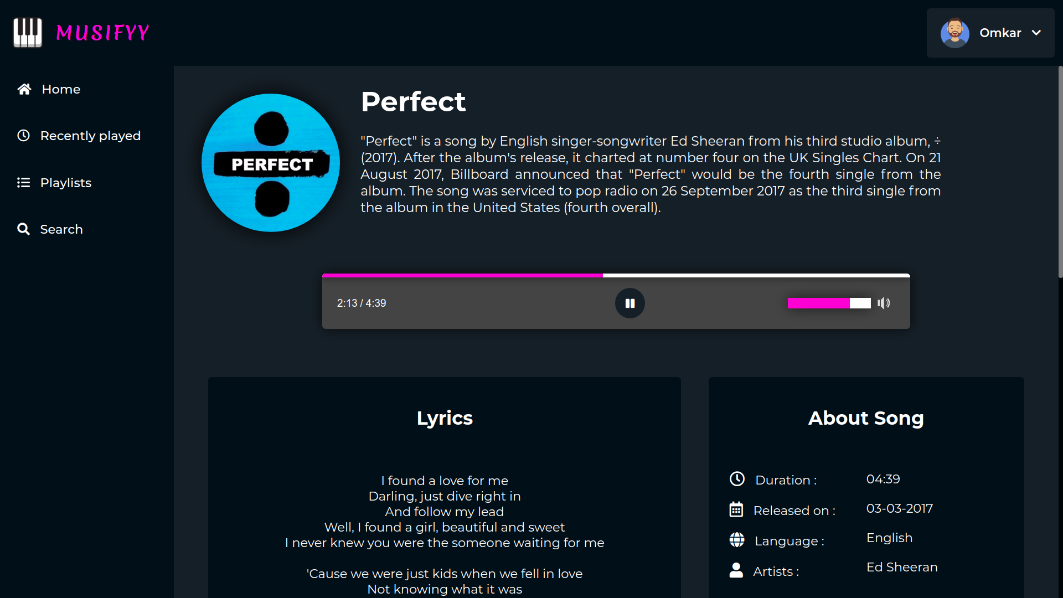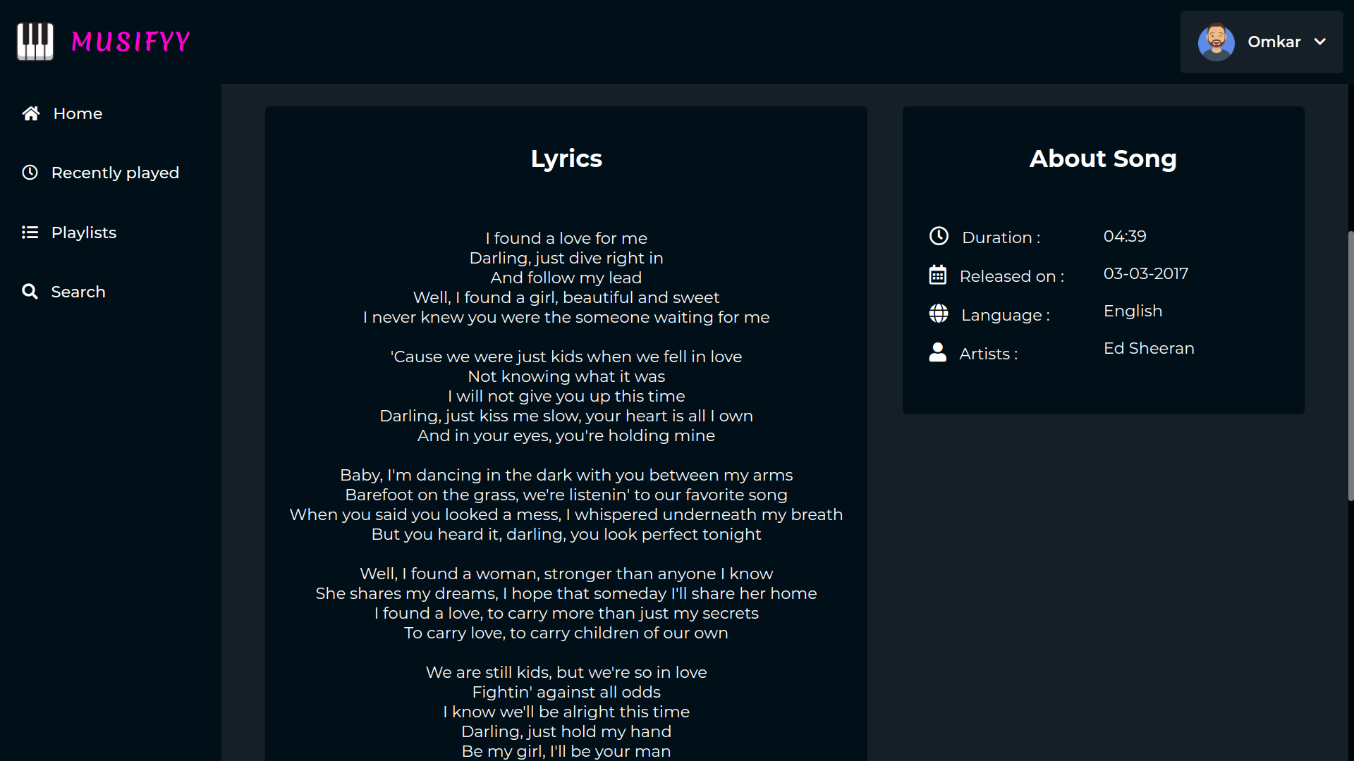

**recent.html**

When a user clicks on the ‘recently played’ tab in the sidebar menu, they are redirected to this page. This page displays a list of recently played songs in a table manner.

The user can also click on the song title to play the song.

Basic tags such as <ul>, <li>, <img>, <a> were used to implement the functionalities.

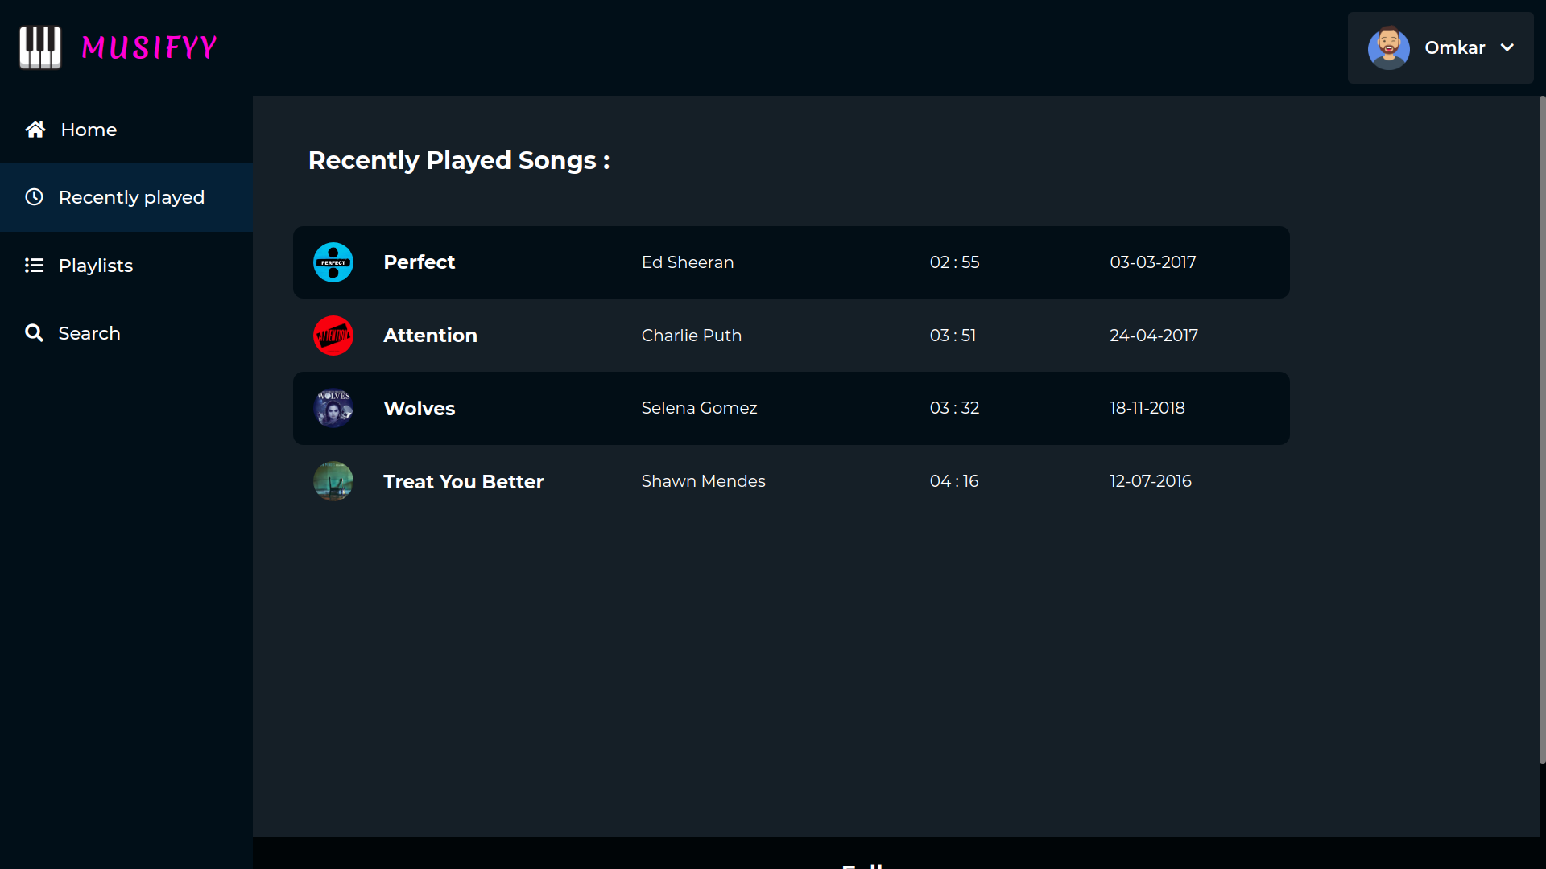

**playlists.html**

When a user clicks on the ‘playlists’ tab in the sidebar menu, they are redirected to this page. This page displays a list of different playlists in a grid of thumbnails.

The user can also click on the thumbnail to view the songs in that playlists.

Basic tags such as <ul>, <li>, <img>, <a> were used to implement the functionalities.

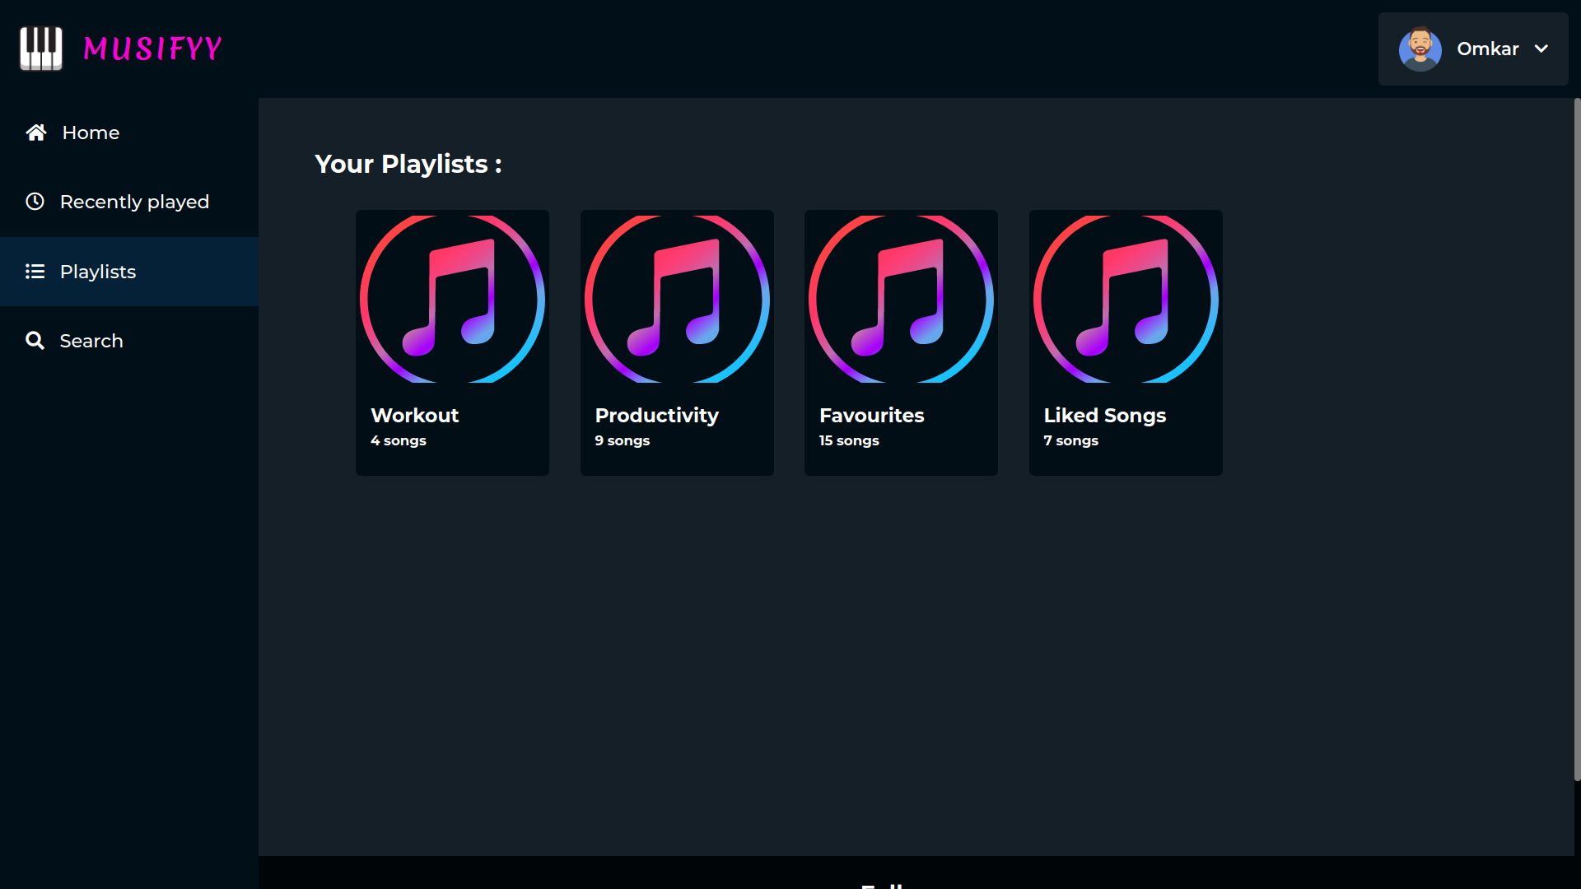

**search.html**

When a user clicks on the ‘search’ tab in the sidebar menu, they are redirected to this page. This page contains a search box in the navbar area. When a user starts typing something in the search box, the songs whose title contains the phrase entered by the user are displayed in a list format dynamically. If the matching songs are not found, it shows the appropriate message on the screen.

Basic tags such as <ul>, <li>, <img>, <a> were used to implement the functionalities. Javascript was used to implement the logic behind searching the songs and displaying them on the page dynamically.

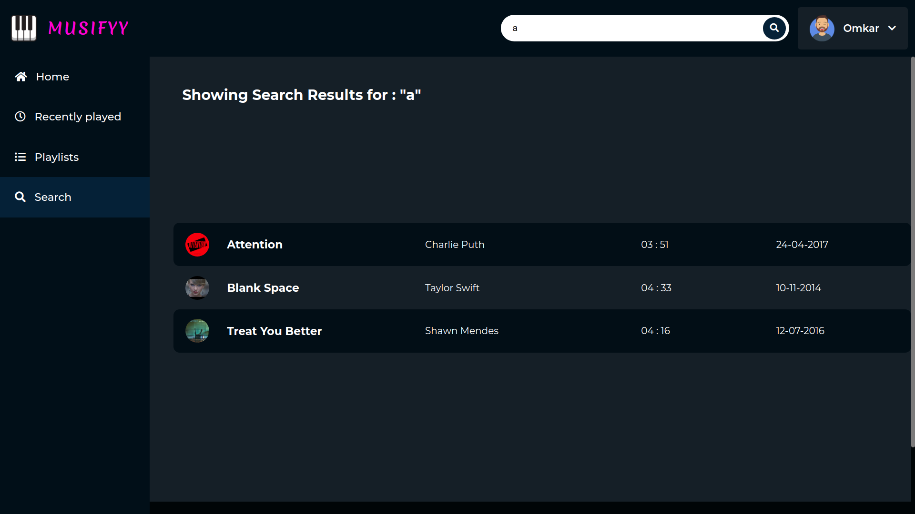

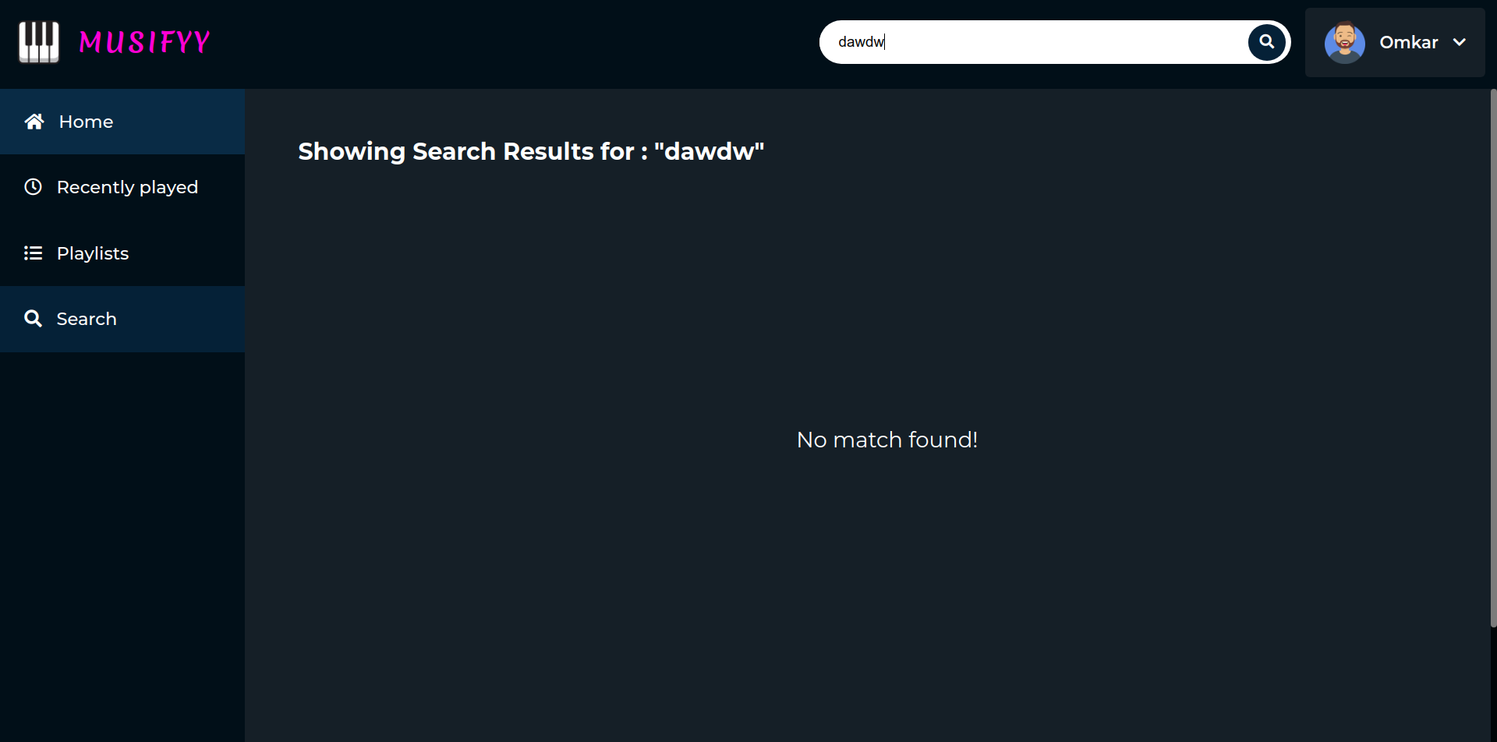

**CHAPTER 5**

**CONCLUSION**

This project has successfully covered the main objectives and goals discussed previously. Some additional functionalities were also added to the project which would enhance the overall user experience. This project would be useful for people interested in listening to their favourite music and will provide them an enriched and personalised music experience. This project is undertaken to provide a free and uninterrupted music streaming facility to its users.

**REFERENCES**

[1] https://open.spotify.com/

[2] https://gaana.com/

[3] https://www.jiosaavn.com/

[4] <https://fontawesome.com/icons>

[5] https://fonts.google.com/specimen/Montserrat

[6] <https://developer.mozilla.org/en-US/docs/Web/JavaScript>

[7] https://developer.mozilla.org/en-US/docs/Web/CSS